Spring 2021

IET 384

Integrated Production Systems II

Project Deliverable 2

Due Date: 02/05/2021 17:00 sharp

Student Name | Student ID

Feedback/Comments:
Grade: /100

Facility Design Project-Part 1

- Purpose of the Project
This assignment is about designing facility layout plans of a large, multi-facility hospital. It is expected and obligatory that students bring together multiple aspects and knowledge they have learned so far in their college education. They need to provide thorough analysis of every task they have on hand, and once they finish, they should be able to present their results on a professionally written report.

- Project Background
Royale Hayat Hospital (RHH), is a pioneer in the medical industry and is one of the best luxury hospitals with excellent services. It also offers a great facility fitted with the state-of-the art medical equipment for the upper and middle class in the society. Royale Hayat Hospital cuts through between offering the conventional medical services and the hotel services characterized with both comfort and luxury. The facility with headquarters in Kuwait is one of the biggest ones in the region and has a distinguishable characteristic of blending between human and artistic scales that aim to offer therapeutic features needed in hospitals. The medical facility seeks to provide a good environment for patients to receive quality medical treatments with attractable features for families such as post-natal care, birthing, planning and conception. The history of this hospital displays the indigenous culture of the middle East in nurturing good practices that makes it to evolve to its multi-disciplinary prover that offers consortium for good patient care with modern medicine in the luxurious and private surroundings.

Main Tasks of the Project:

- Production of a respirator that is used in the prevention of VAP
- Determination of the new facility location in Kuwait
- Departmentalization of the facility where the respirator is produced
- Redesign of some departments of Royal Hospital

- VAP Respirator Project (200%)
Ventilator associated pneumonia is a type of lung infection that occurs in people who are on mechanical ventilation breathing machines in hospitals. As such, VAP typically affects critically ill persons that are in an intensive care unit (ICU). Since the whole world is going through a war with Covid-19, each and every hospital has to fulfill its responsibilities in ICUs. VAP emerges if the patient is lying on the bed in horizontal position rather than angled. In some solution bundles provided, these respirators have bending angles, they are moving up and down and sidewise to allow movement of patient, which is crucial in preventing VAP. The respirator also plays a key role in VAP since failure to disinfect them or unguided usage of them may lead to VAP in hospitalized patients. Royal Hayat has sufficient funding from government and other private authorities, which is why they have the capacity to be able to produce their own respirators. Currently, they are considering to open a facility to produce these respirators and they are proud of their own design, which they created using IET program engineering teams in ACM.
As the engineering team, you are expected to answer the following questions:
  - Develop an exploded assembly tree of your own, original respirator (25 Points): Here, you are expected to provide an original design that is used to reflect a real respirator. You can draw on a paper and take the picture and put it in this word file.
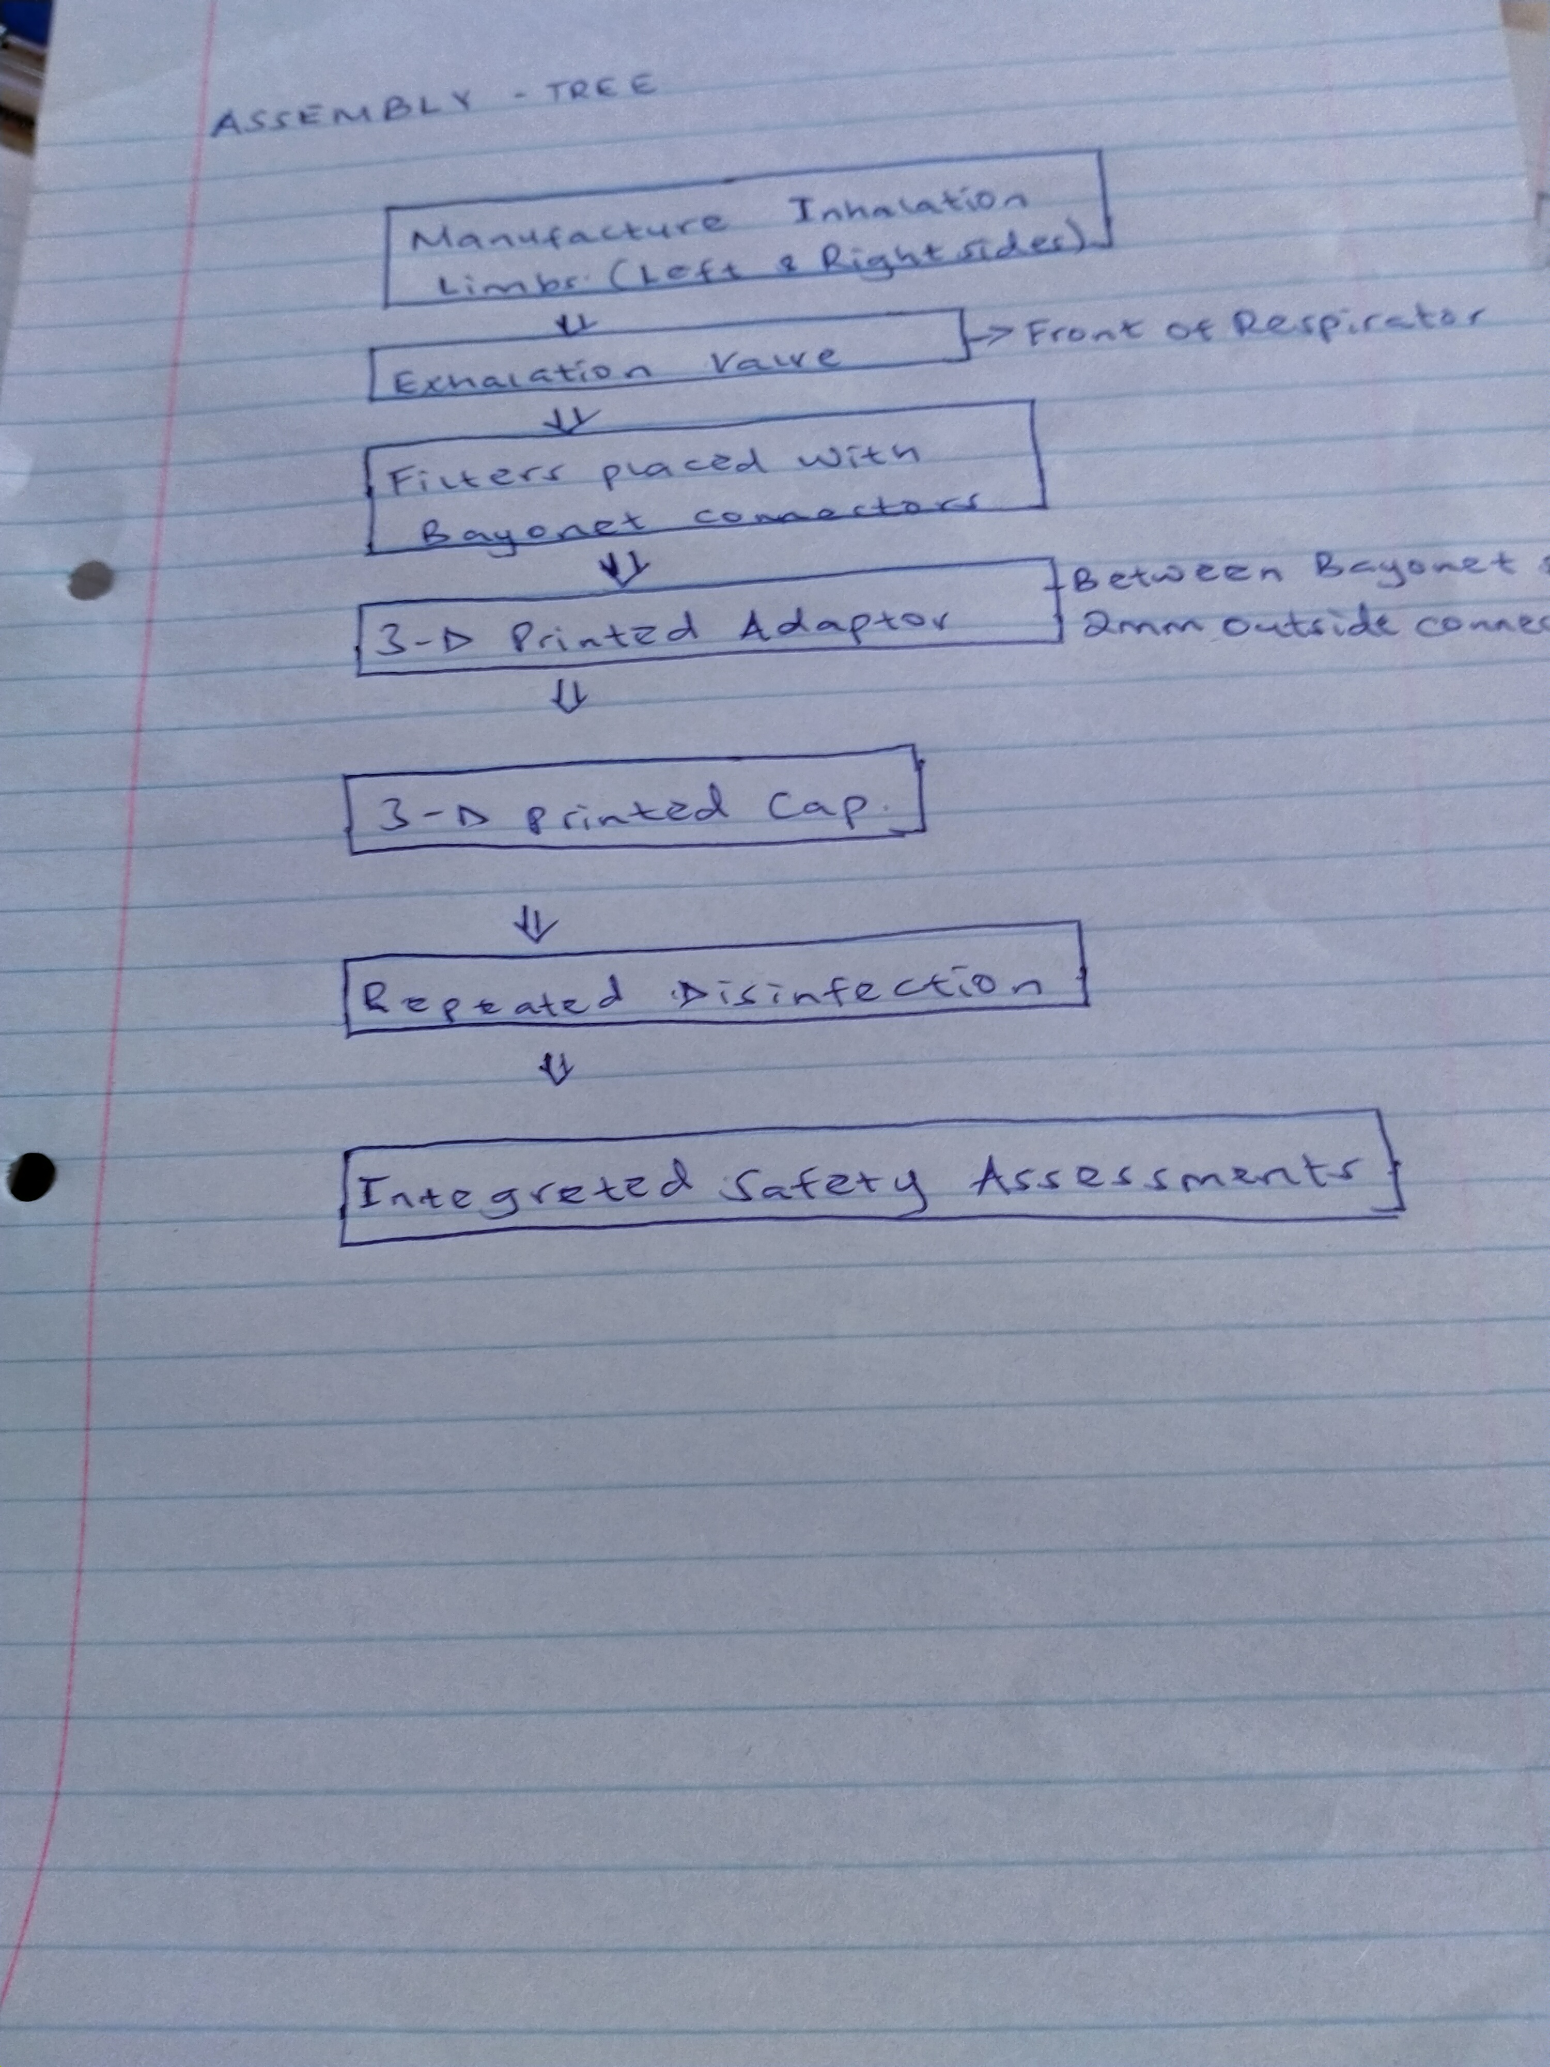
  - Develop also the BOM tree of your patient respirator (20 Points): You need to have at least 3 levels BOM tree, in which you have to include main body parts, tires and bending mechanism. Make use of your searching ability to find a comprehensive BOM tree and apply it to your own design.
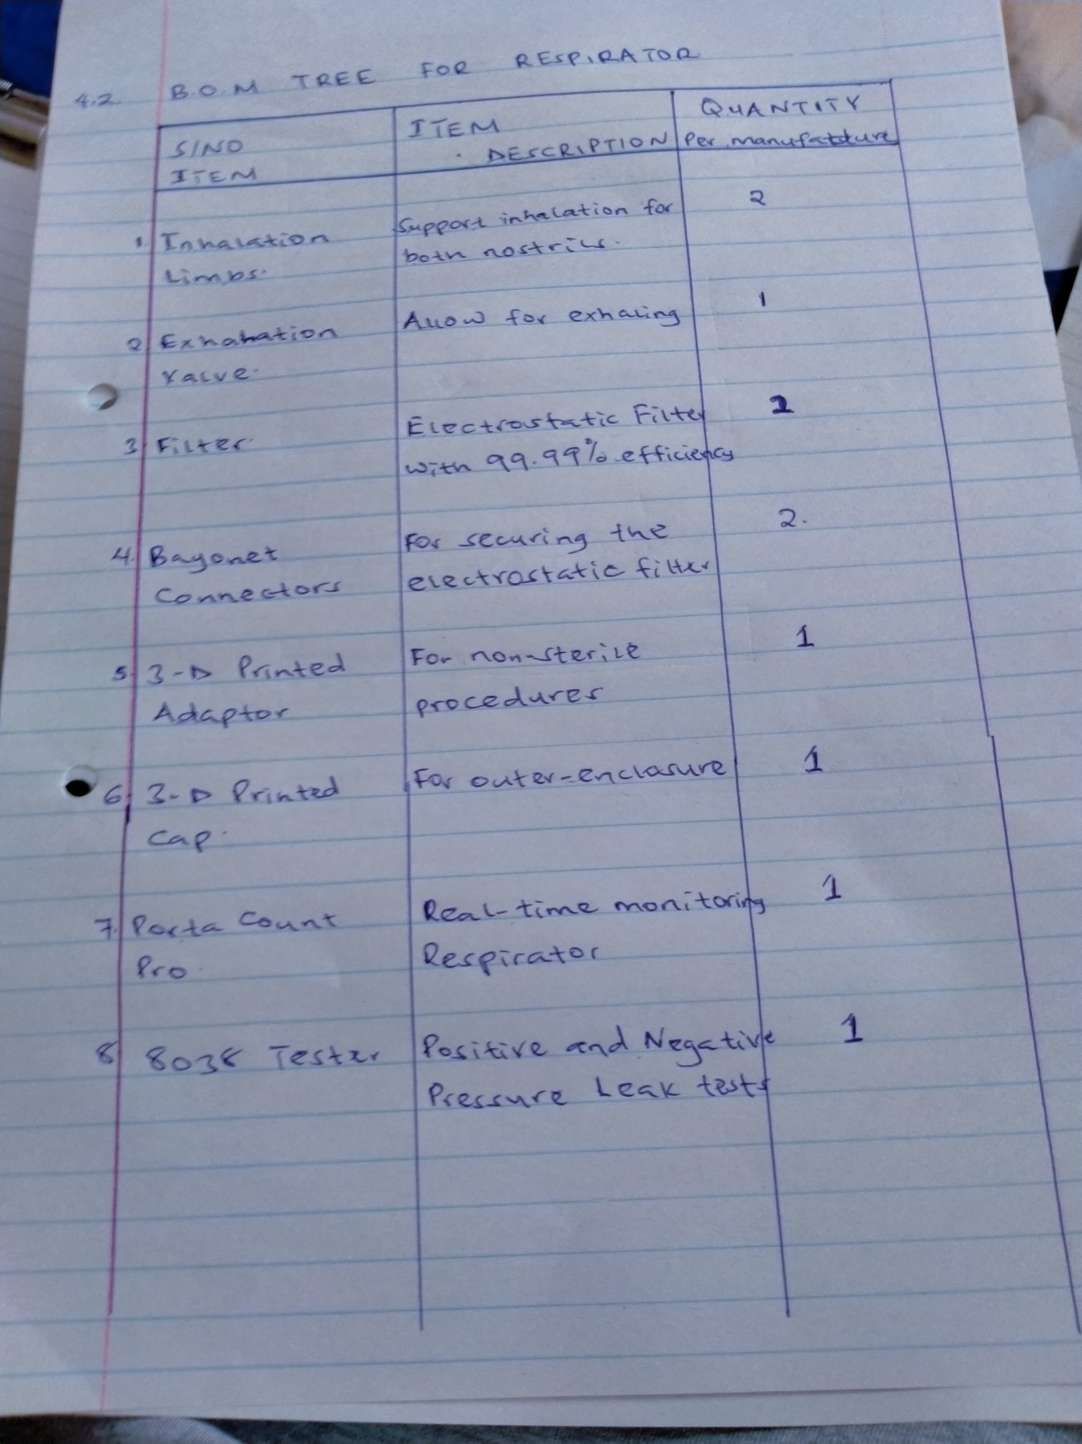
  - Make the part list (20 Points): Based on your BOM tree, create the part list and specify dimensions, part names, and the decisions of MAKE-BUY in the list. Additionally, explain why you need to make or buy the associated part. Show your justification clearly.
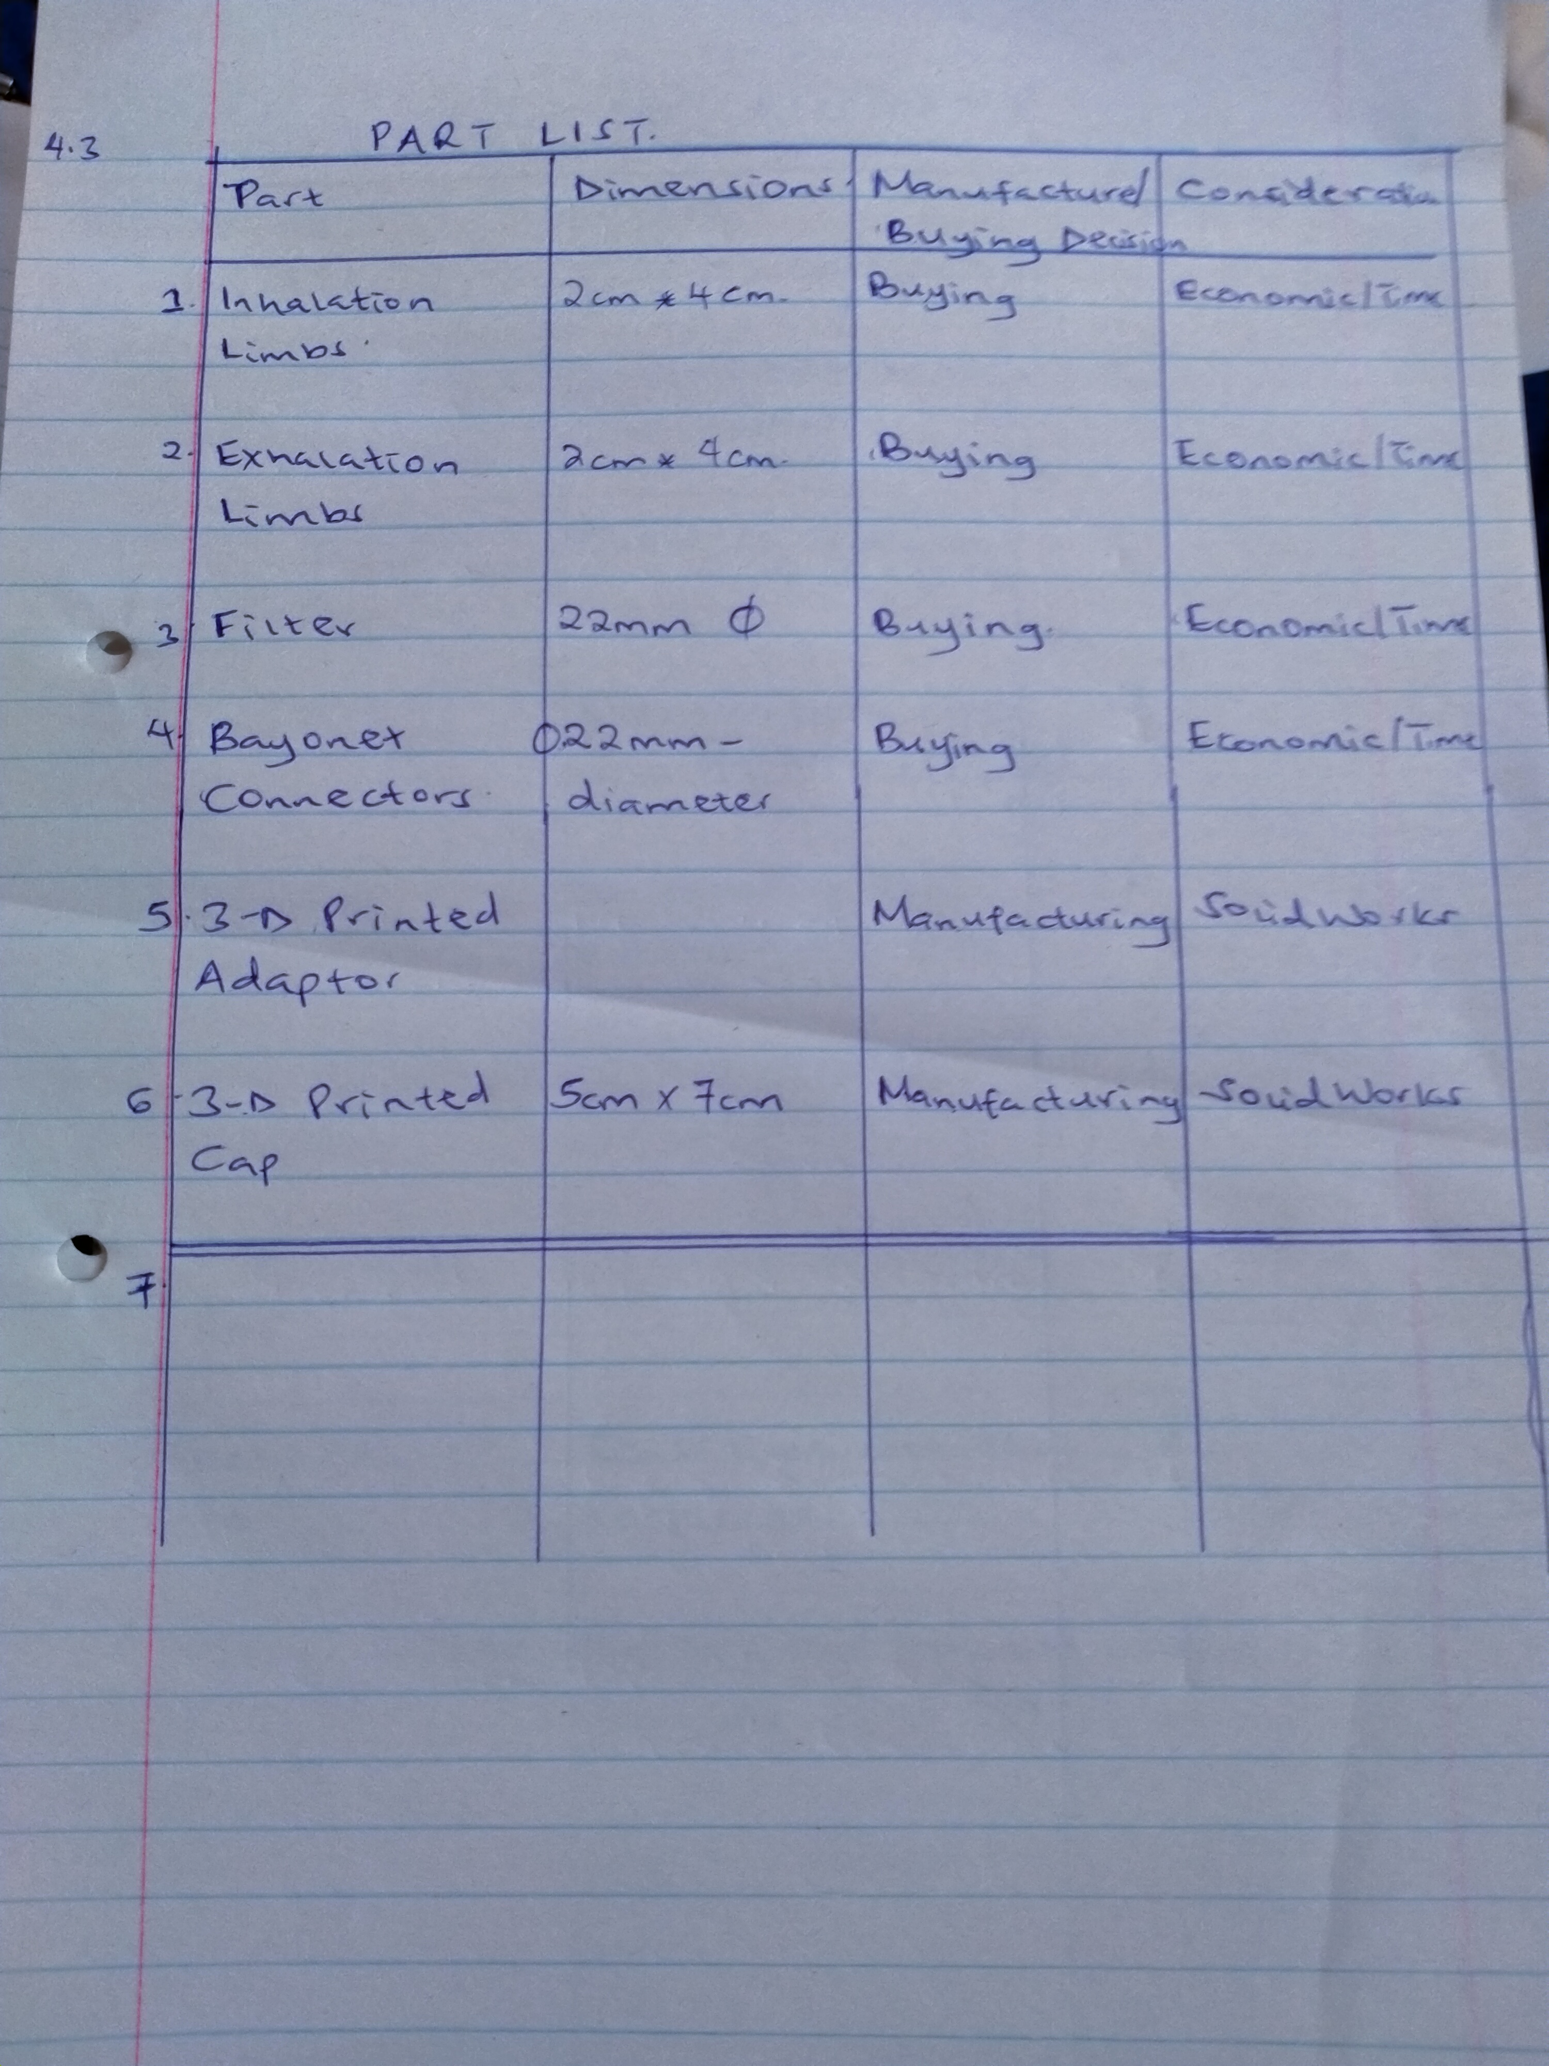v
  - Provide the operation process chart of the respirator (20 Points): On a separate A4 paper, draw the chart or use flow chart tools in Word to create one. Your operation process chart should have at least 10 processes and subparts as you might understand from your BOM tree and parts list.
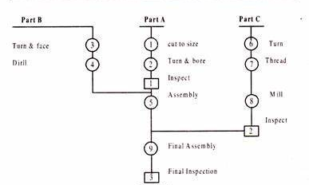
Figure 1: Illustrating the operational process chart.
  - Determine number of inputs required for your operations (40 Points): Since they also plan to sell the respirators in GCC, Royal Hayat estimates a high demand coming from other hospitals. They used a private firm to obtain past sales data of a substitute product for benchmarking and they have the following demand data:
Period -5 | Period -4 | Period -3 | Period -2 | Period -1 | Period 0
875 | 696 | 774 | 781 | 793 | 804
    - Use single exponential smoothing to estimate current period’s demand. Assume F₋₅ = 830. Note that you are trying to find next period, which is Period 1. (10 Points)
Answer: Period 2

    - Since you determine your processes in question 4.4, estimate and assign defect rates to your processes along with your reasoning. (10 Points)
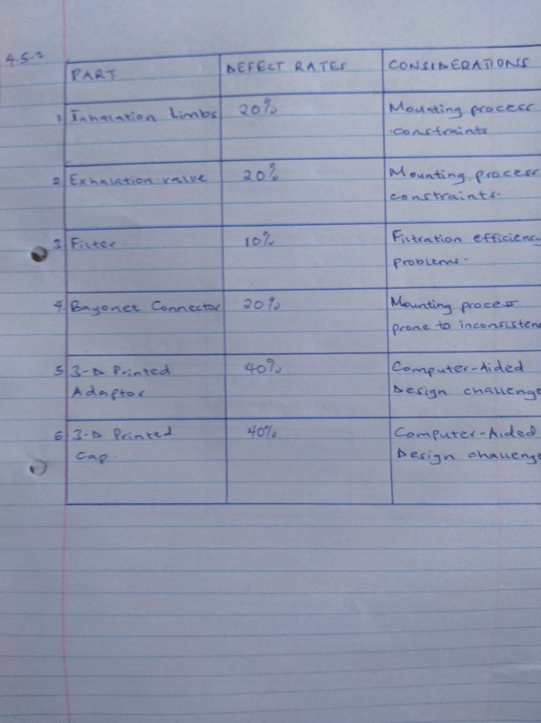
    - Determine all input levels of your operations using the defect rates you assigned and the demand rate you calculated in question 4.5.1. (10 Points)
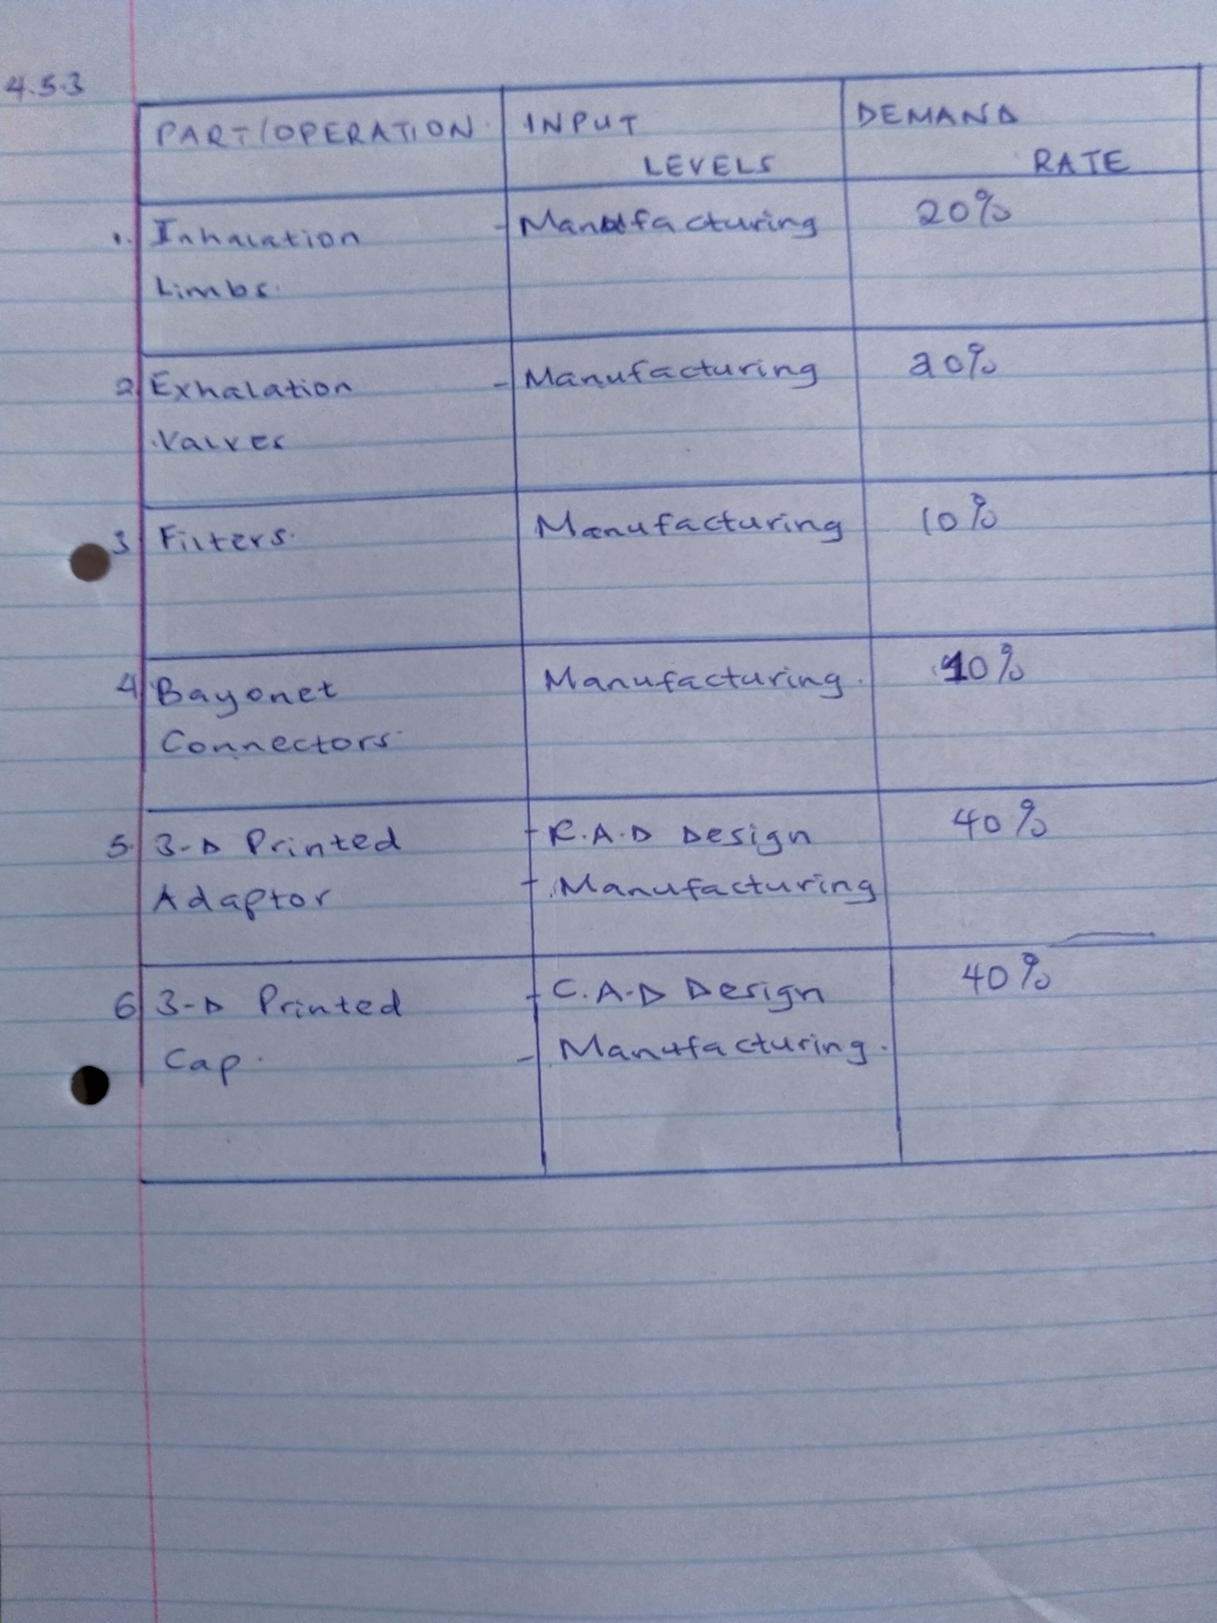
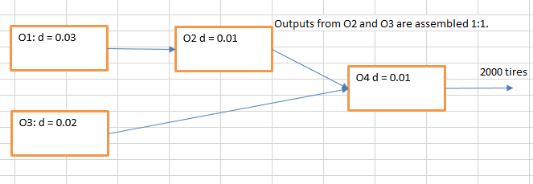
    - As an additional requirement, the following process chain is obtained for the tires of your respirator:

Determine the input levels of each operation. (10 Points)
Input levels 02 and O4 both with d equal to 0.01
  - Determine the number of machines in the facility (25 Points): Composing mostly of assembly stations and welding machines, Royal Hayat has to determine the number of machines required per shift in the facility. It is assumed that each respiratory requires 42 minutes to assemble, and you already determined your number of items needed for each operation in question 4.5.3. Machines are 90% available due to setup times, and their reliability level currently reaches 95%. If there are 3 shifts per day and 6 hours per shift, determine the total number of machines for each of your operations. Notice that if you have 10 operations, you have to determine 10 different number of machines.
Number of operations = 10
Reliability Level = 0.95
Available machines = 0.90
Number of machines = (0.95*6*3+ 10)* 0.90 = 19.26 thus 19 Machines needed
  - Considering Royal Hayat is based on Jabriya, explain in at least 500 words where you would put the facility to produce respirators. You have to discuss at least 5 factors and explain your reasoning by providing sufficient proof. You have to explain how you will bring the respirator, how will you make subcontracts, contracts with logistics, which road to use, lead times, raw materials to bring to your facility and so on. Your grade will be determined based on your ability to provide details and support of ideas. (50 Points)
The first factor is the integration management structure that includes all the activities involved in setting up the respirator assembly. It extends to the general infrastructure needed to meet the safety and quality requirements. In uwait it includes the medical device regulations defined by the Ministry of Health. Drug and Food control but in international terms it includes the necessary requirements from the World Health Organization. Additionaly it includes the need to meet the quality control standards and the need to attain safety of consumer plus the use of such respirators in modern healthcare systems. Such medical requirement include the “ Law of Soud Food and Drug Authority,” Article Five abbreviated as 25/1/1428H as issued from the Royal Decree. The regulations makes it clear that Saudi Food and Drug Authority should monitor the health care equipment plus their conformity with their safe operation with other medical devices.
The second factor is the scope associated with this respirator that includes the responsibilities of each stakeholder, healthcare providers handling the final respirators, the internal biomedical engineering department plus the requirements of all third part service contractors. Also it includes the manufactuer instructions for the PPM and CM, accuracy of the inventory information and maintenance management system, pre-installation and pre-procurement of medical devices, listing of manufactured respirators with market authorization or listing numbers, review of published data with respect to technical difficulties.
The third factor is the resources associated in the assembly of this respirators; scheduling, human-related and organization. The scheduling includes the time frames needed to complete manufacturing the respirators in meeting the local and international demands. The human-resources includes the labor and compensation schemes of workers both technical and non-technical all working to deliver quality respirators for the general public. The organizational includes the financial resources needed to set-up the infrastructure, train the team members, manage the sales, logistics and marketing ventures. In this part the most important factor is the source of these funds and direct/indirect costs involved in manufacturing the respirators.
The fourth factor is the risk management involved in overcoming the manufacturing defect rates. It includes the technological/innovational risk associated with future improvement in the structure, aesthetics or working of the current respirators and how it should meet international expectations. Ethical and legal risks composed of the regulations, policies and standards from a local, regional and international perspective. The social/cultural risks attributed to various norms and practices by the citizens that affect directly or indirectly the finished product of these respirators. Finally the economic risk that includes the competition from other manufacturing firms producing respirators.
The fifth factor is the logistics and procurement management. It includes the routes used to transport the manufactured respirator, acquisition of raw materials and the movement of the human resource personnel from the places of residence. The safest route is through the Fourth Ring road that connects with Al Maghreb Road to Kuwait City.
Important Note: Notice that based on your assumptions, design and thinking, each and every group gets different answers to these questions. Therefore, what you say, what you do, what you defend in your report is more important than simply obtaining an answer. Keep that in mind and always use systemic approach to this project, define your assumptions clearly and support them with your mind.

- Department Redesign Project (100%)
Once they determine the production quantities for patient respirators, it is now time to deal with the current layout of Royal Hayat, which has many departments inside its building in Jabriya. The departments to be dealt with are obstetrics (O), gynecology (G), women’s health (WH), pediatrics (P), neonatal unit (NU), internal medicine (IM), general and laparoscopic surgery (GLS), cosmetic center (CC), dermatology (D), ear, nose and throat (EST), dental clinic (DC), pain management (PM), intensive care unit (ICU), laboratory (L), and clinical pharmacy (CP). In addition, the hospital has waiting rooms, reception, and a payment point. The hospital considers different patient types that are flowing through these departments.
Patient 1: Regular patient who visits the hospital one time per month or per two months for routine control.
Patient 2: Pregnant women who visit for routine control or it is the birth of their baby and they stay 2-3 days in the hospital.
Patient 3: Random patients who come for sickness, cough, fever, dent problems and so on.
Patient 4: Patients who come with severe injury or immediate problems and enter the hospital through emergency.
Patient 5: Dental clinic patients
Patient 6: Medicine seeking
Patient 7: Obstetrics
Patient 8: ICU
Patient 4 is two times more important than Patient 1 and Patient 3, and Patient 2 is two times more important than Patient 4, as the pregnant women with kids are very crucial. All other patients have the same importance level assigned.
The following flow table has been obtained by patient movement analysis for around 2 months:
Patient Type | Number of Patients | Routing
Patient 1 | 850 | WH-P-WH-L-IM-WH
Patient 2 | 2400 | G-O-WH-GLS-G-WH-IM-WH-PM-G-O-WH-L-WH
Patient 3 | 1200 | EST-L-EST-NU-P-D-EST
Patient 4 | 750 | D-PM-NU-GLS-P-IM-P-D
Patient 5 | 440 | DC-PM-DC-IM-DC-CP
Patient 6 | 650 | IM-PM-L-IM-PM-IM-CP
Patient 7 | 380 | O-CC-O-PM-IM-CC-CP
Patient 8 | 500 | ICU-GLS-WH-ICU-IM-PM-ICU
  - Determine the From-To Matrix for the departments. (20 Points)

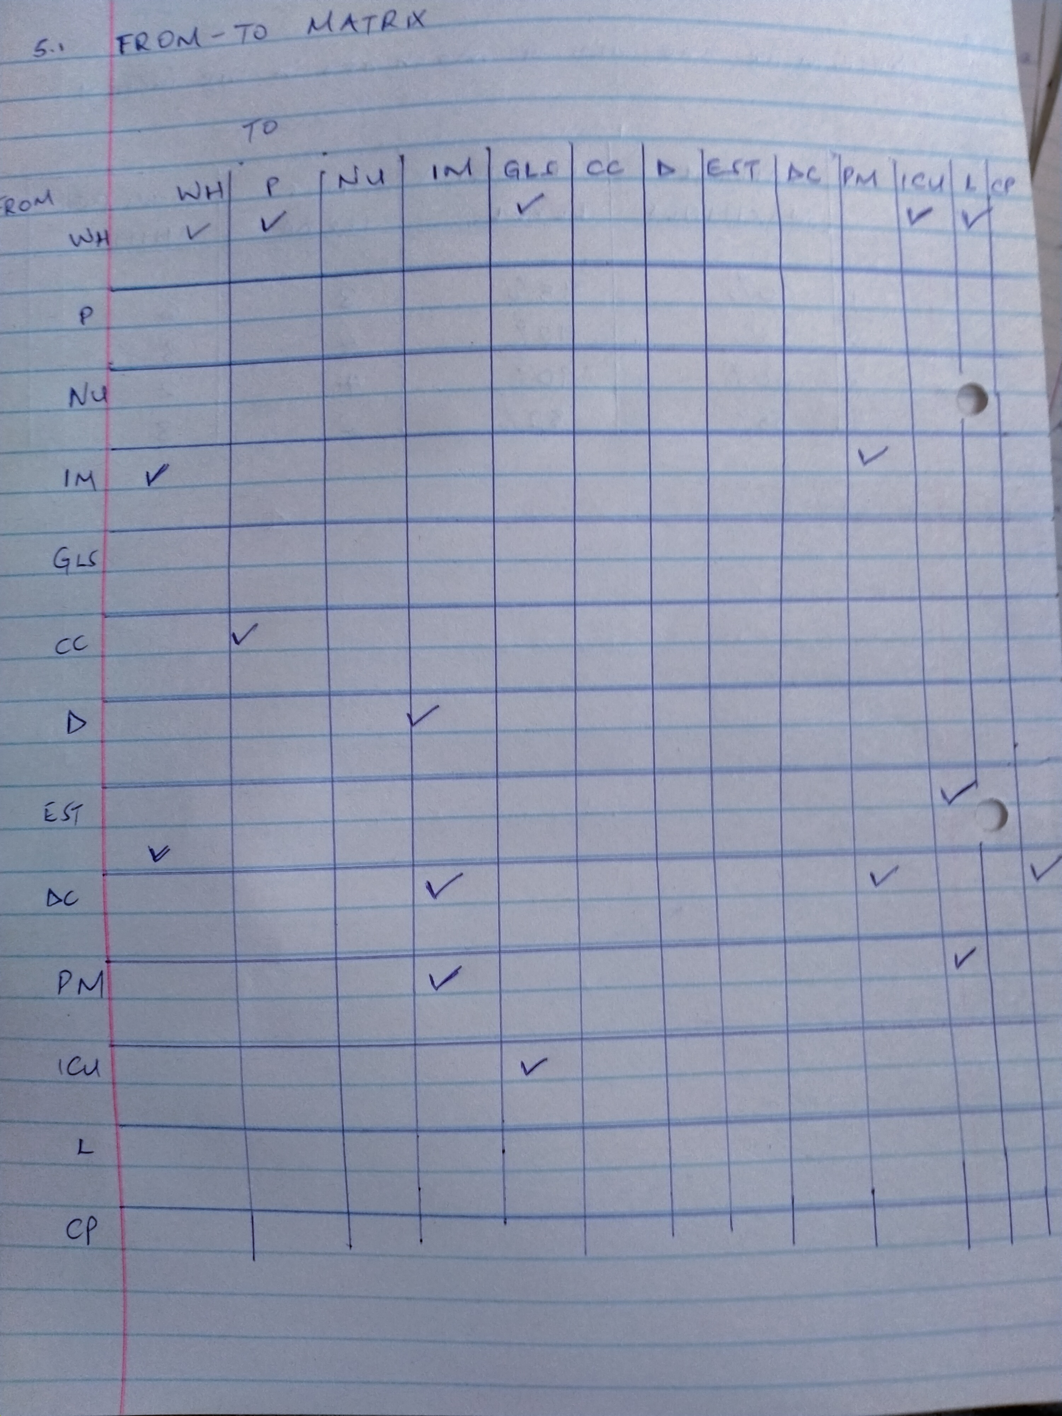
  - If the current layout is given as follows, determine the distance matrix. (20 Points)
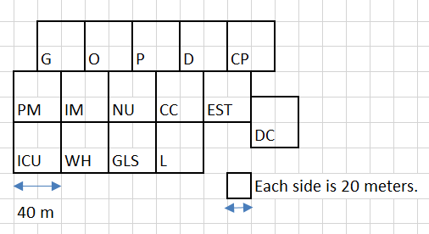

  - Calculate the total cost consisting of flow and distance. (10 Points)
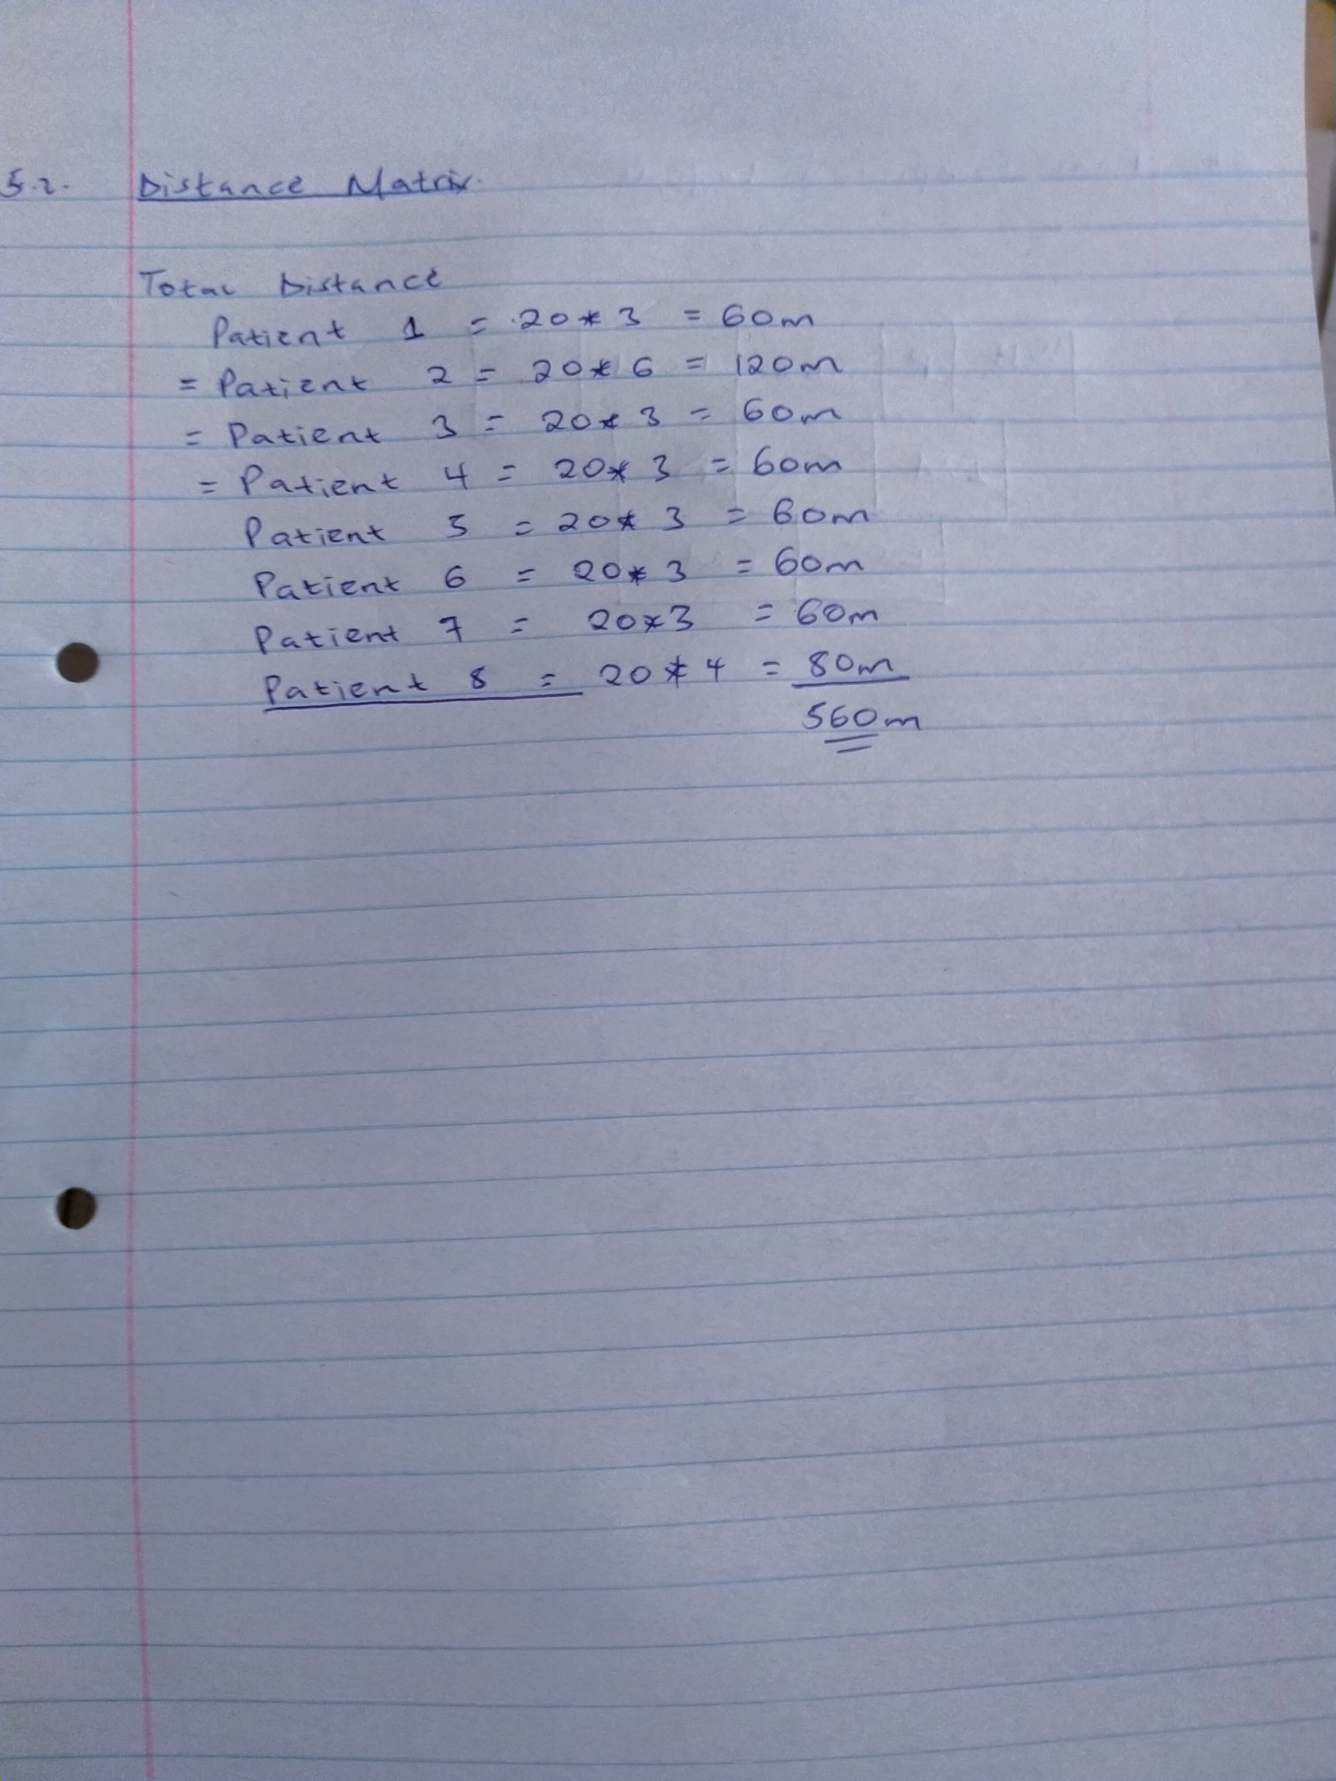
  - The managerial office asks you to re-locate the departments based on the From-To Matrix. Arrange the new hospital layout using Excel or draw it on a large paper and take the picture of it. (20 Points)
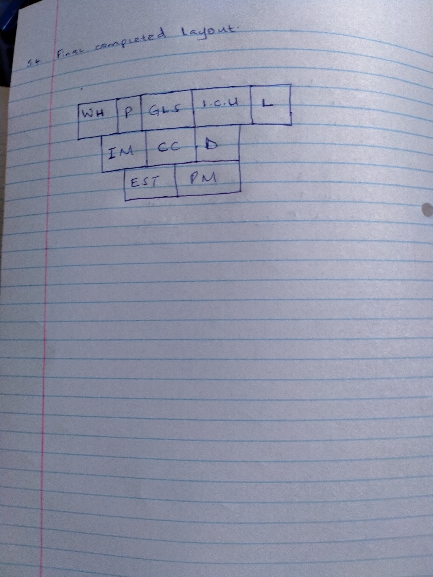
  - Based on the new plan you designed, calculate the new distance matrix. (10 Points)
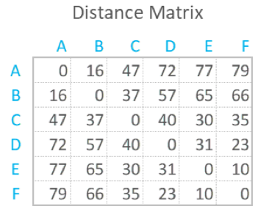
  - There should be nurses patrolling in the departments of ICU, GLS, WH and EST. If the minimum number of nurses are given below, construct a linear programming model to minimize the total cost. Assume each and every nurse is paid 20 KD per day worked. (10 Points)
Day | ICU | GLS | WH | EST
Sunday | 24 | 19 | 22 | 19
Monday | 27 | 23 | 23 | 28
Tuesday | 29 | 22 | 24 | 23
Wednesday | 33 | 25 | 25 | 24
Thursday | 25 | 23 | 22 | 21
Friday | 12 | 11 | 10 | 11
Saturday | 14 | 10 | 13 | 11

